Oil Blend Class Example
You work for an oil company. (How evil of you!) You’re assigned the task of deciding what blend of crude from three different fields in Saskatchewan to use in producing four grades of gasoline: regular (87 octane), mid (89), high (91), and supreme (93). Regular and mid can contain up to 2% sulfur, but high and supreme can contain no more than 1%. You can buy up to 6000 barrels per day from each of the three fields, and costs per barrel of these crudes, along with octane and sulfur content, are given in the table below.
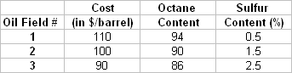
The minimum demand and selling price for each grade of gasoline is given as below.
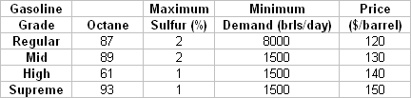
Regardless of which crude it is coming from and which grade it is going into, it costs $7 per barrel to process the crude into gasoline. You can increase demand above these minima by advertising, but the advertising is grade specific. For each dollar spent on advertising a particular grade of gasoline, you sell 5 more barrels. Assume that storage is expensive, so you are producing and selling on a day-by-day basis. What should be your plan to maximize profit?

Max Z = 3x₁₁ + 13x₁₂ + 23x₁₃ + 33x₁₄ + 13x₂₁ + 23x₂₂ + 33x₂₃ + 43x₂₄
+ 23x₃₁ + 33x₃₂ + 43x₃₃ + 53x₃₄ - a₁ - a₂ - a₃ - a₄
s.t.
x₁₁ + x₁₂ + x₁₃ + x₁₄  6000 c1
x₂₁ + x₂₂ + x₂₃ + x₂₄ 6000 c2
x₃₁ + x₃₂ + x₃₃ + x₃₄ 6000 c3
x₁₁ + x₂₁ + x₃₁ - 5a₁ = 8000 c4
x₁₂ + x₂₂ + x₃₂ - 5a₂ = 1500 c5
x₁₃ + x₂₃ + x₃₃ - 5a₃ = 1500 c6
x₁₄ + x₂₄ + x₃₄ - 5a₄ = 1500 c7
-7x₁₁ - 3x₂₁ + x₃₁ 0 c8
-5x₁₂ - x₂₂ + 3x₃₂ 0 c9
-3x₁₃ + x₂₃ + 5x₃₃ 0 c10
- x₁₄ + 3x₂₄ + 7x₃₄ 0 c11
-1.5x₁₁ - 0.5x₂₁ +0.5x₃₁ 0 c12
-1.5x₁₂ - 0.5x₂₂ + 0.5x₃₂ 0 c13
-0.5x₁₃ + 0.5x₂₃ + 1.5x₃₃ 0 c14
- 0.5x₁₄ + 0.5x₂₄ + 1.5x₃₄ 0 c15

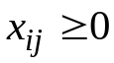, 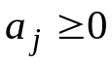 for all 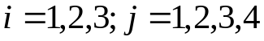
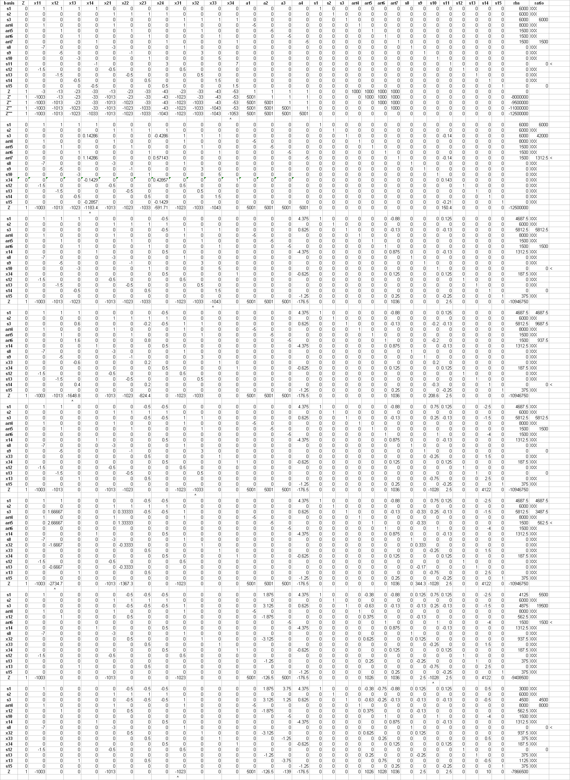

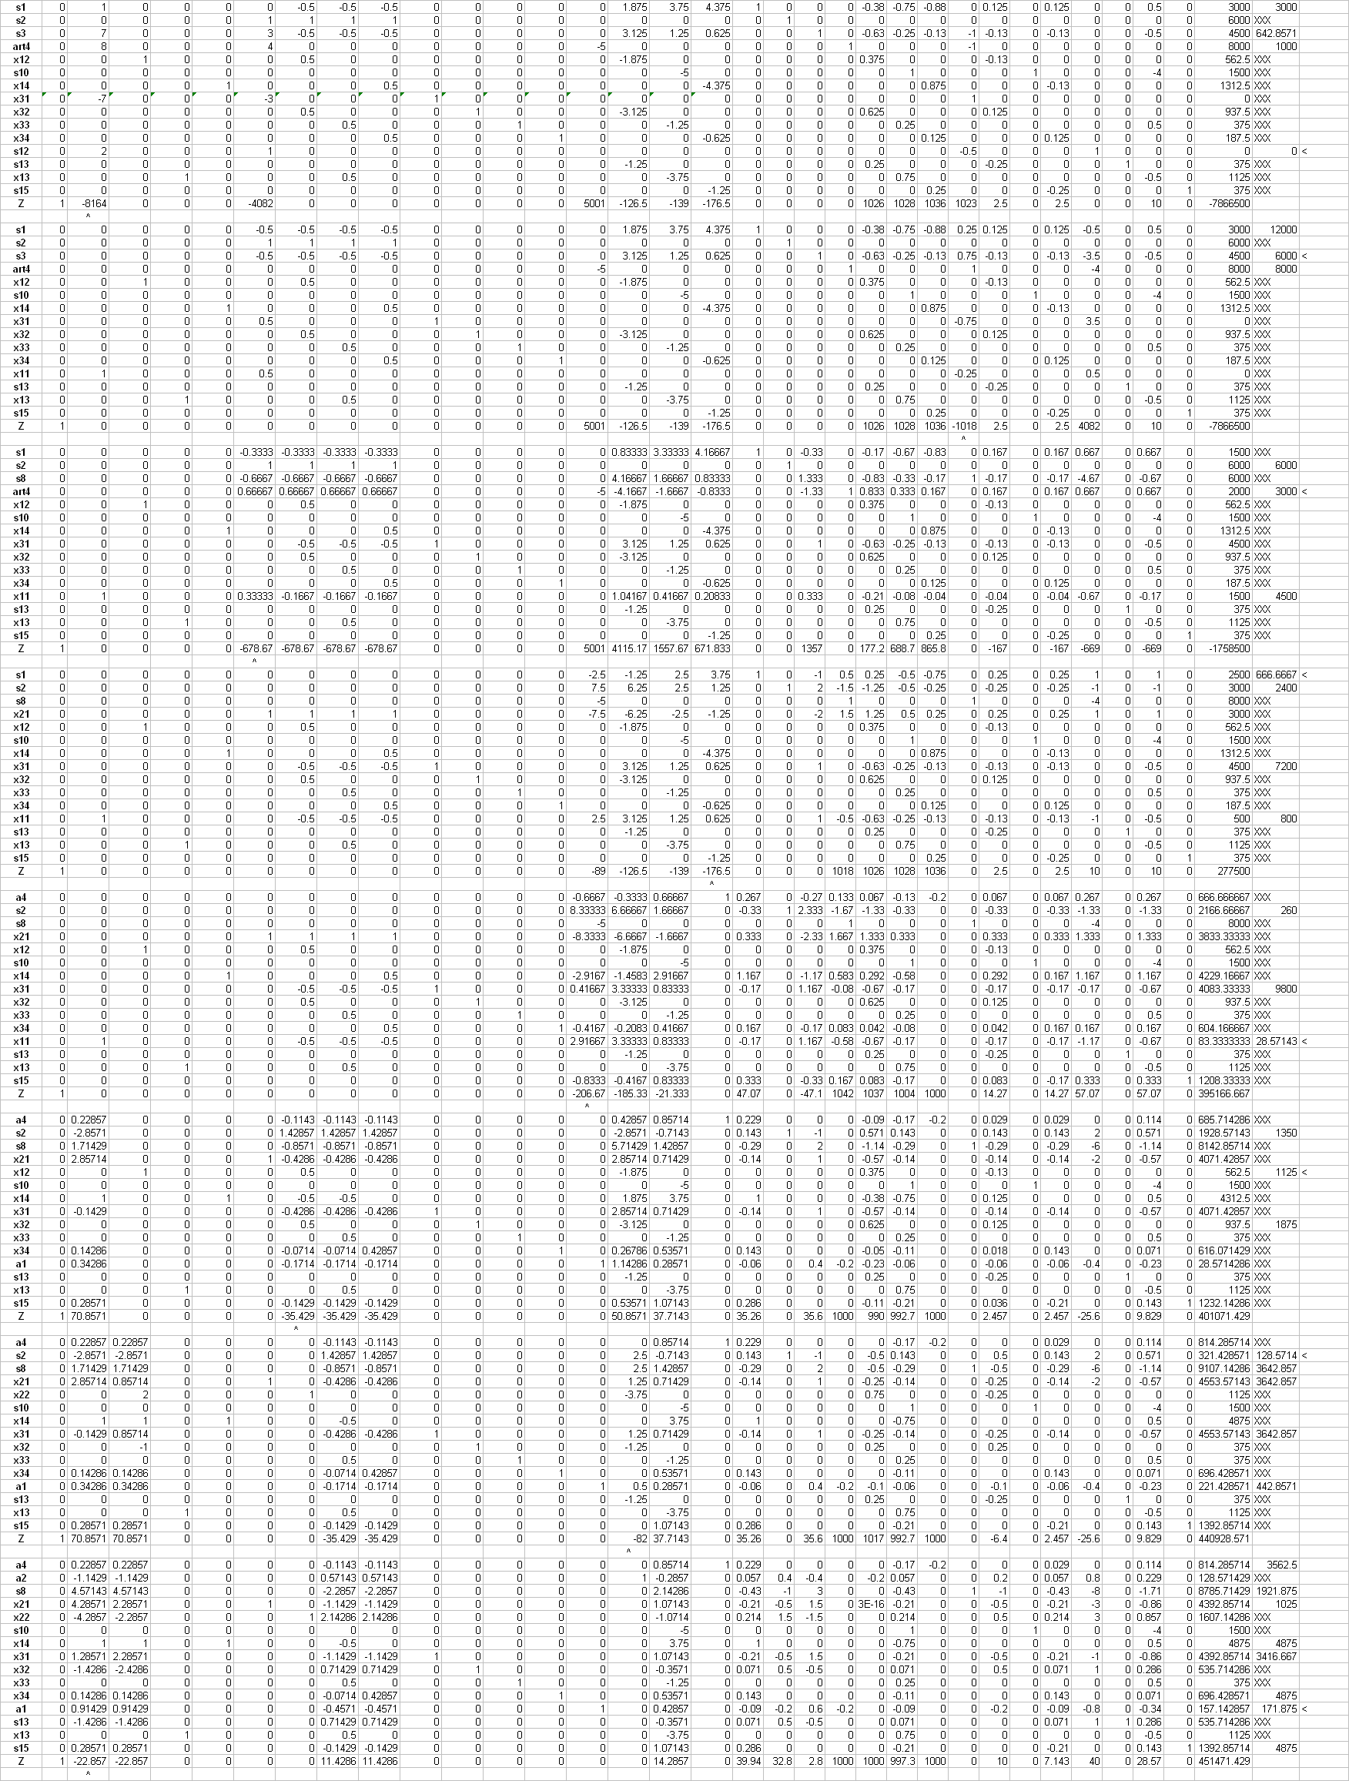

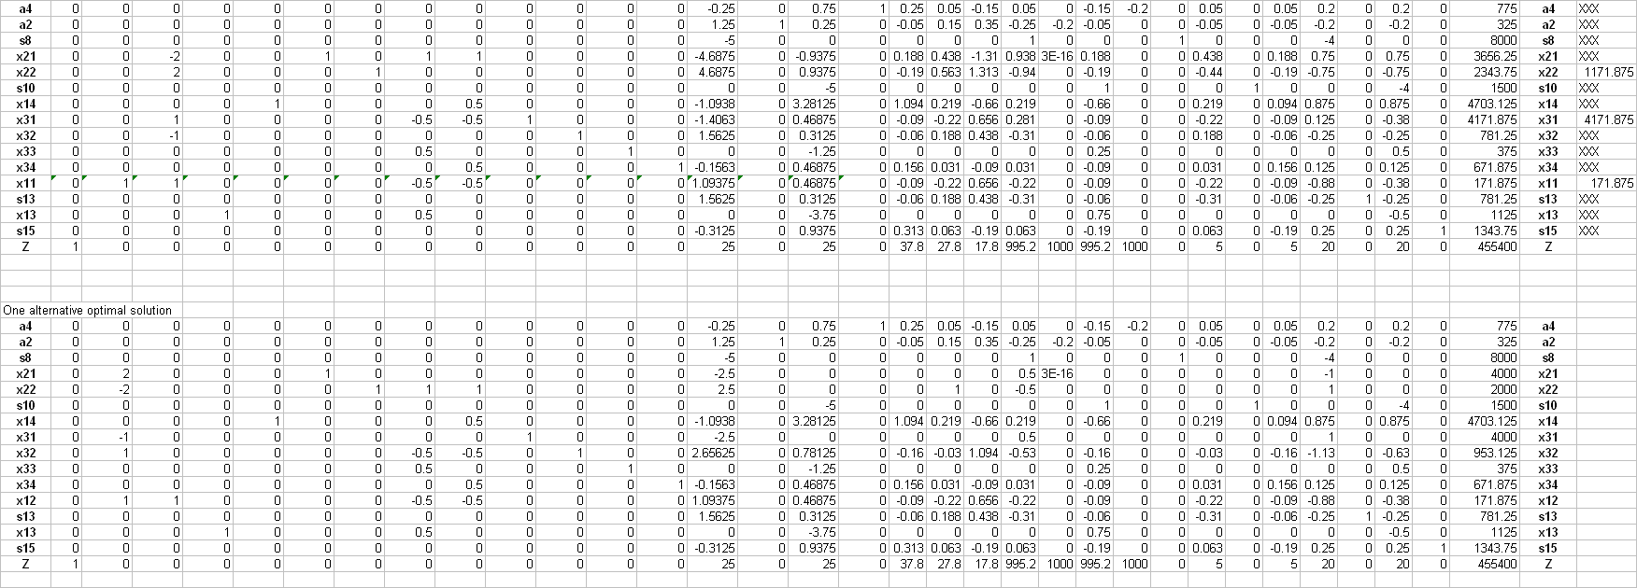

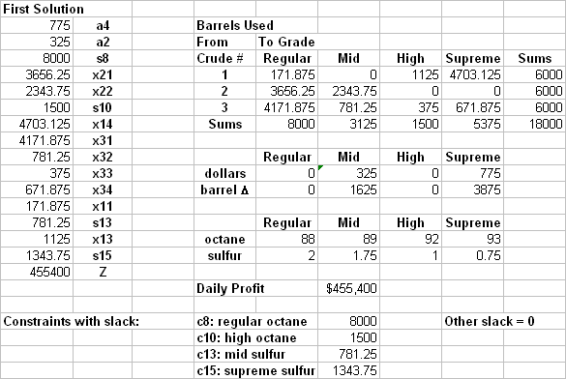

One alternative
